Ans.1

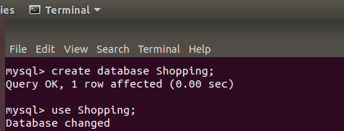

Ans.2

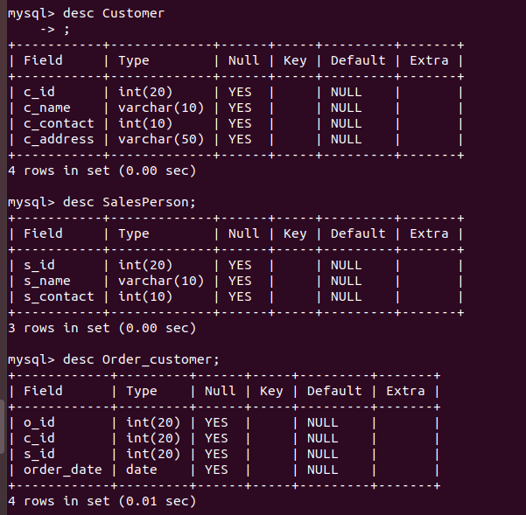

Ans.3

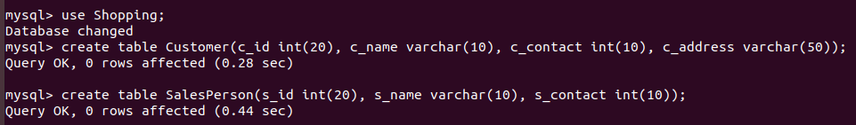

Ans.4

Inserting data into **Customer** table

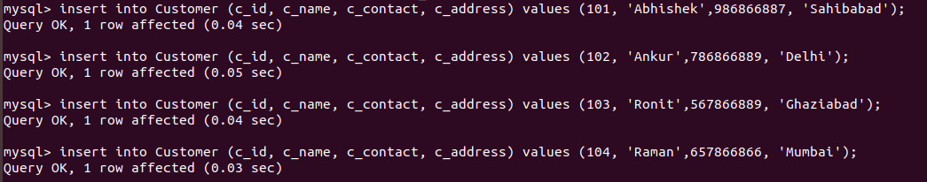

Inserting data into **SalesPerson** table

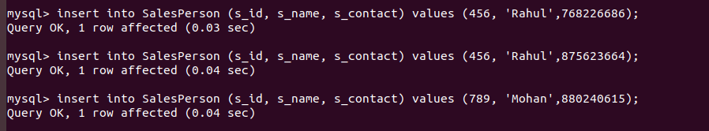

Inserting data into **Order_customer** table

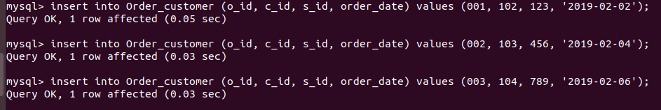

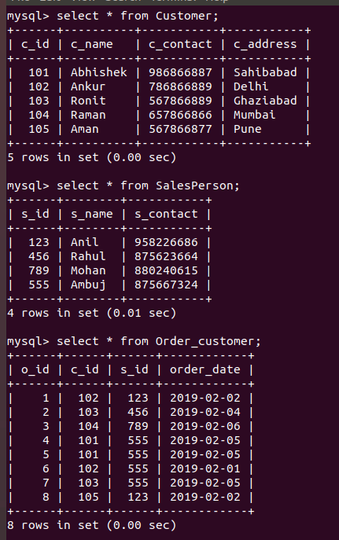

Ans.5

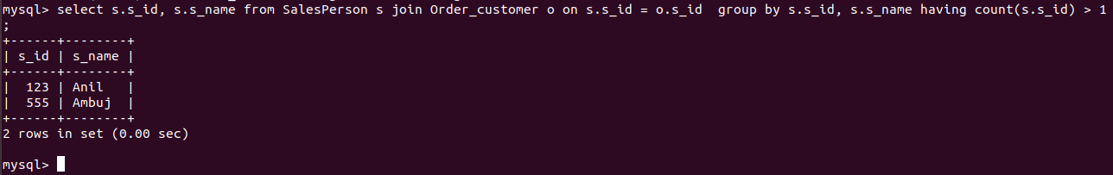

Ans.6

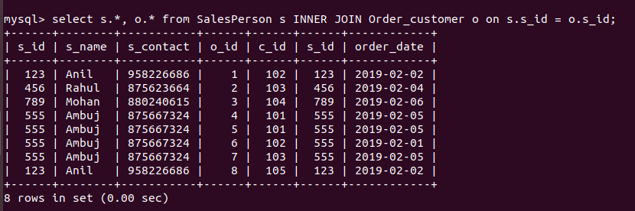

Ans. 7 and 8.

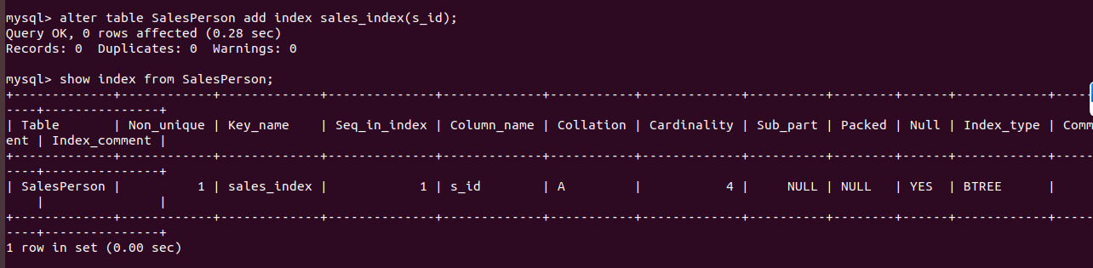

Ans.9